Put the title of the paper here with font Arial, size 16 pt,
length up to 2 lines

First+Middle+Last Name∗1(*:Corresponding, 1:Affiliation), Second Author^{2a(a:footnote info (optional))}, Third Author^{2b}

¹Affiliation (Department, Institute, Address, Country) with font Arial, size 9.5pt
²Department of Civil Engineering, Korea Advanced Institute of Science and Technology,
291 Daehak-ro, Yuseong-gu, Daejeon 34141, Republic of Korea

(Received leave as blank, Revised leave as blank, Accepted leave as blank)

Abstract. The abstract should be written in Times New Roman with a font size of 10.5 pt. This abstract is provided as a placeholder for formatting and layout purposes only. It demonstrates the recommended structure, length, and style of an abstract in this journal. Authors should briefly state the research background, objectives, methods, key findings, and conclusions in a clear and concise manner. The abstract should be written as a single paragraph and should not include references, figures, or equations. Upon manuscript submission, this text must be replaced with the author’s actual abstract.

Keywords: (List the keywords in alphabetical order and in lower case) formatting guideline; journal template; manuscript preparation; placeholder

1. Introduction

This section provides a brief introduction to the manuscript structure and formatting style required by the journal. The text shown here is dummy content intended only to demonstrate layout, font usage, spacing, and citation style. Authors must replace all placeholder text with their own content upon submission.
This section should be written in Times New Roman with a font size of 11 pt. Numerical in-text citations should be indicated using square brackets, such as [1], [2], or multiple references as [3-5].

2. Section title: Level 1 (Font Arial, size 11 pt, bold)

This section demonstrates how to format section and subsection headings, equations, figures, and tables.
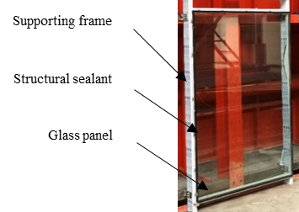 | 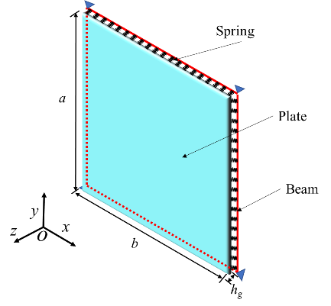
(a) A figure caption | (b) A figure caption
Figure 1. Example of a figure caption (Font Times New Roman, size 10 pt)

Figure 2. Example of a figure caption

2.1 Subsection title (Font Arial, size 11 pt)

Figures should be cited in the text as Fig. 1. Each figure must have a caption placed below the figure. The proposed method can be described using both text and mathematical expressions. Equations should be centered and numbered consecutively on the right-hand side, as shown in Eq. (1).
$$F=ma$$ | (1)
where F denotes force, m is mass, and a is acceleration. If multiple equations are used, they should be referenced in the text as Eq. (1) or Eqs. (1)-(4).
$$E={mc}^{2}$$ | (2)
$$v=d/t$$ | (3)
$$E_{k}=\frac{1}{2}{mv}^{2}$$ | (4)
Table 1. Example table used for formatting demonstration (Font Times New Roman, size 10 pt)
Glass | E_{g} (Pa) | 70×10⁹
Glass | v_{g} | 0.22
Glass | ρ_{g} (kg/m³) | 2500
Supporting frame | E_{f} (Pa) | 70×10⁹
Supporting frame | v_{f} | 0.33
Supporting frame | ρ_{f} (kg/m³) | 2700
Structural sealant | E_{s} (Pa) | 1×10⁶

3. Section title: Level 1 (Font Arial, size 11 pt, bold)

Tables should be cited as Table 1, with captions placed above the table.

3.1 Subsection title: Level 2 (Font Arial, size 11 pt)

The manuscript may include sections, subsections, and sub-subsections, numbered as 3, 3.1, and 3.1.1.

3.1.1 Sub-subsection: Level 3 (Font Arial, size 11 pt)
The content here is for demonstration purposes only and shows how citations, figures, and tables should be referenced in the text. Previous studies have adopted similar approaches for presenting methodological frameworks and experimental procedures [1, 2]. Additional related discussions can be found in the literature [3-5].
As shown in Fig. 1(a) and Fig. 2, the workflow consists of sequential steps designed to ensure clarity and reproducibility. The variables listed in Table 2 are defined to provide a concise overview of the model inputs and assumptions [6].

Level 4 heading
This subsection presents placeholder text to illustrate how authors should structure and format the main body of the manuscript [7-9]. Previous studies by Kim et al. [2] demonstrated that the proposed method improves numerical stability.

4. Conclusions

Through numerical simulations and illustrative analyses of the proposed model, the following conclusions can be drawn:
(1) The proposed framework consists of simplified components representing the main structural elements, which can be idealized using a basic analytical model. By applying a standard formulation method, the governing equations can be derived and expressed in a form suitable for numerical implementation.
(2) The accuracy of the calculated results improves as the number of assumed functions increases, showing clear convergence behavior. For practical applications, a limited number of functions is sufficient to achieve stable and reliable results with reasonable computational effort.
(3) The comparison between the illustrative results and reference values demonstrates good agreement, indicating that the adopted approach is appropriate for demonstrating the analysis procedure and formatting requirements of this journal.
(4) These results confirm that the present template effectively illustrates the recommended structure, numbering style, and formatting of the conclusions section. This dummy text should be replaced with actual research findings upon manuscript submission.

Acknowledgements

This section is optional. Authors may acknowledge funding sources or individuals who contributed to the work.

References

- Author(s) (Year). Title of paper (Capital letter only for the first letter). Name of Journal, Volume number, page-page. DOI address.
- Cheng, Y.F., Xu, B.M., Carter, G.D. (2012). A comparison of large…… Computers and Concrete, 91(4), 1301-1328. https://doi.org/10.12989/cac.2012.91.4.1301.
- Author(s) (Year). Name of book (Capital letter only for the first letter). Name of publishing company, City, State, Country.
- Bathe, K.J. (2014). Finite element procedures. Klaus-Jürgen Bathe, Watertown, MA, USA.
- Kurowicka, D., Cooke, R.M. (2005). Distribution-free continuous Bayesian belief nets. Modern statistical and mathematical methods in reliability. World Scientific, Singapore.
- Author(s) (Year). Title of paper. Name of proceeding or name of occasion (Capital letter only for the first letter), City, Month.
- Kerciku, A.A., Bhattacharya, S., Burd, H.J., Lubkowski, Z.A. (2008). Fixity of pile foundations……. Proceedings of the 14th world conference on earthquake engineering, Bejing, China, October.
- Author(s) (Year). Title (Capital letter only for the first letter). Ph.D. Dissertation, Name of University, City.
- Sajjad, M. (2005). Evaluation of bacterial strategies. Ph.D. Dissertation, Michigan State University, East Lansing, MI, USA.
- Design code (Year). Title (Capital letter only for the first letter). Name of Organization, City, Country.
- ACI 318 (2011). Building code requirements for structural concrete and commentary. American Concrete Institute, Farmington Hills, MI, USA.
- Author(s) (Year). Title (Capital letter only for the first letter). Research Report Number, Name of University/Institution, City, Country.
- Wu, Y.F., Oehlers, D.J., Griffith, M.C. (2001). Numerical simulation of composite plated columns. Research Report No. R172, Department of Civil and Environmental Engineering, Adelaide University, Adelaide, Australia.

∗Corresponding author, Academic title (e.g., Professor, Ph.D.), E-mail: email@domain.com ª Ph.D., E-mail: email@domain.com ^{b} Ph.D., E-mail: email@domain.com

